Yohanes Dimas Pratama

A11.2021.13254 - A15.9102

Reusable Water Bottle

1. Product Name

Reusable Water Bottle

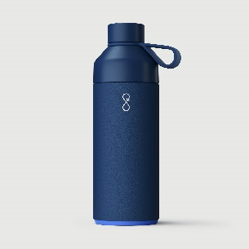

1. Product Description:

Introducing our Stainless Steel Reusable Water Bottle – the perfect companion for your active and eco-conscious lifestyle. Crafted with precision and sustainability in mind, this sleek and durable water bottle is designed to make a positive impact on your hydration routine and the environment.

1. Materials of the Product

Made from high-quality, BPA-free, and food-grade stainless steel.

1. The Advantages of the Product

* Environmentally Friendly

Reduces the need for single-use plastic bottles, contributing to a decrease in plastic waste.

* Durability

Stainless steel construction ensures a long lifespan for the bottle.

* Temperature Retention

Keeps beverages hot or cold for an extended period.

1. The Disadvantages of the Product

* Weight

Stainless steel bottles can be heavier than their plastic counterparts.

* Cost

Initial purchase cost might be higher compared to disposable plastic bottles.

1. The Package to Use

* Eco-Friendly Packaging

Minimalistic and recyclable packaging to align with the product's eco-friendly nature.

* Informational Insert

Include a small leaflet or tag providing information on the environmental benefits of using a reusable bottle, care instructions, and product features.

This example demonstrates how a reusable water bottle made from stainless steel can offer environmental advantages and durability. The disadvantage is the potential weight compared to plastic, and the package emphasizes eco-friendliness and includes useful information for the consumer.

Make a positive impact on your health and the environment with our Stainless Steel Reusable Water Bottle. Choose sustainability without compromising on style or functionality. Order yours today and join the movement towards a greener and healthier future.